**CURRICULUM VITAE**

Uladzimir Yeudakimovich

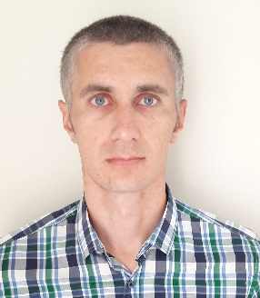

email [uladzimir.yeudakimovich@gmail.com](mailto:uladzimir.yeudakimovich@gmail.com)

website <https://uladzimir-yeudakimovich.github.io>

phone +375 33 3344201

Personal Profile

Software Engineer with experience of creation single page application using frameworks such as Angular, Angular Material, Bootstrap and various libraries, support application written using AngularJS.

Responsible and highly trustworthy with analytical, problem solving and troubleshooting capability. Results oriented and customer focused, with excellent relationship management skills.

Self-motivated and able to work to own initiative, persistent to work under pressure, flexible with the ability to juggle priorities effectively, ambitious to drive the career forward and willing to learn.

Qualifications / Education

* Harvard University, course Computer Science CS50, 2017
* The Rolling Scopes School: front-end development 2017-2018
* Udemy, Angular 7 course, 2018

Languages

* English: B1/B2 level
* Russian: native speaker

IT Skills

Commercial Development Experience:

* Angular
* AngularJS
* Angular material
* Bootstrap
* JavaScript
* REST
* Ajax
* jQuery
* Git
* webpack
* mocha
* selenium
* SASS and LESS
* HTML5 and CSS3

Educational projects:

* Vue
* React
* React Native

Employment History

# Software Engineer, lifetech (Turkcell Group), Minsk

(February 2019 – Present)

Achievements and responsibilities:

* Support and improvement of the application on AngularJS ([https://mylifebox.com](https://mylifebox.com/))
* Adding new features
* Working with REST API
* Work in a team of 5 web developers as a developer, interacting with the product manager, iOs and Android teams, testers and designers.
* Code review for all members of the web team.
* Build project.

# Software Engineer, OCS Innovation Company (OCSICO®), Minsk

(August 2018 – February 2019)

Achievements and responsibilities:

* Creating application on Angular 6 and angular material (<https://ikassa.by>)
* Support application on AngularJS
* Working with REST API
* Independent work as a web developer, interaction with the product manager, designer, Android and backend teams.

Software Engineer, Freelance Web Development, Minsk

(February 2015 – August 2018)

Achievements and responsibilities:

* Creating application on Angular 4 and Bootstrap 4 (<https://www.abamahotelresort.com>)
* Creating application using JavaScript and jQuery
* Working with REST API
* Teamwork of 2 web developers as a developer.